复杂组网截图

As4：

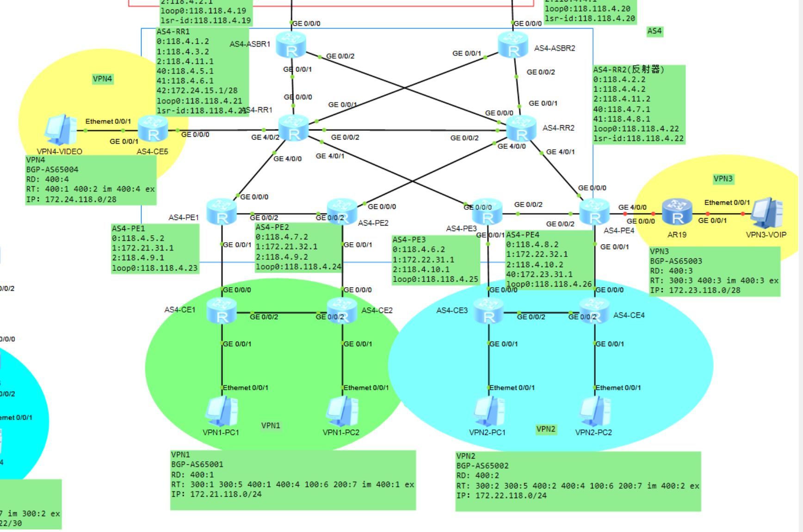

As2：

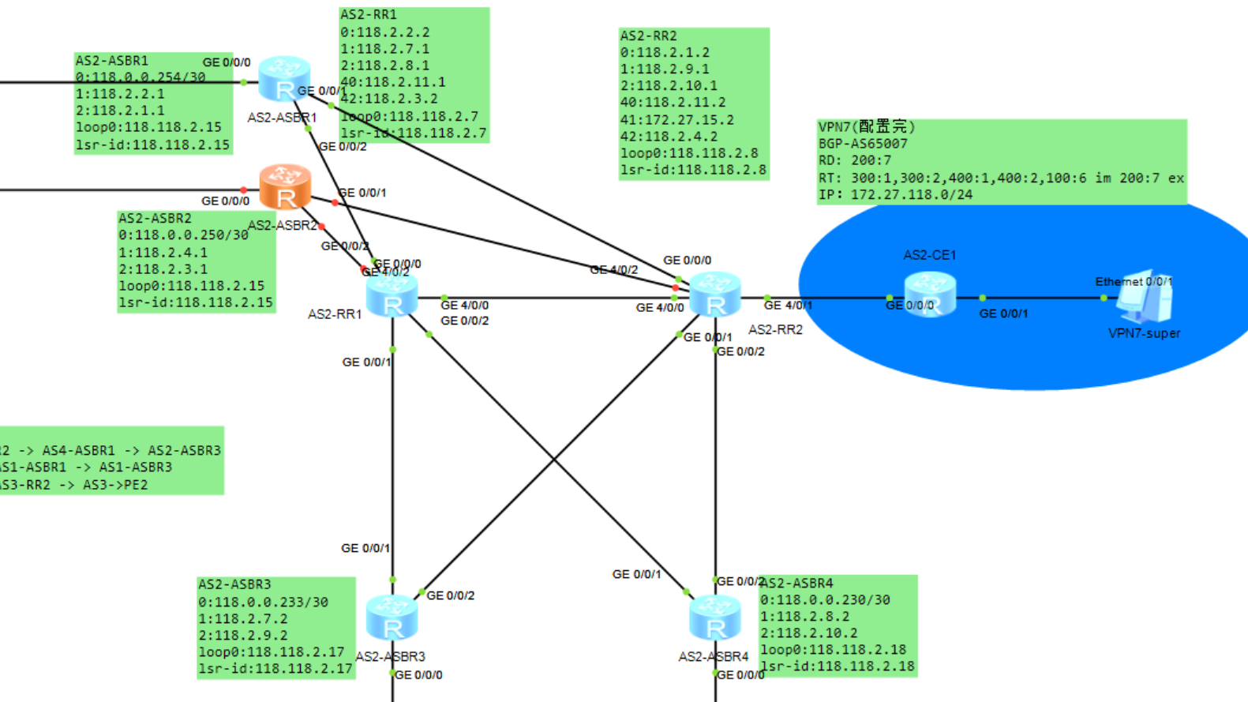

As1:

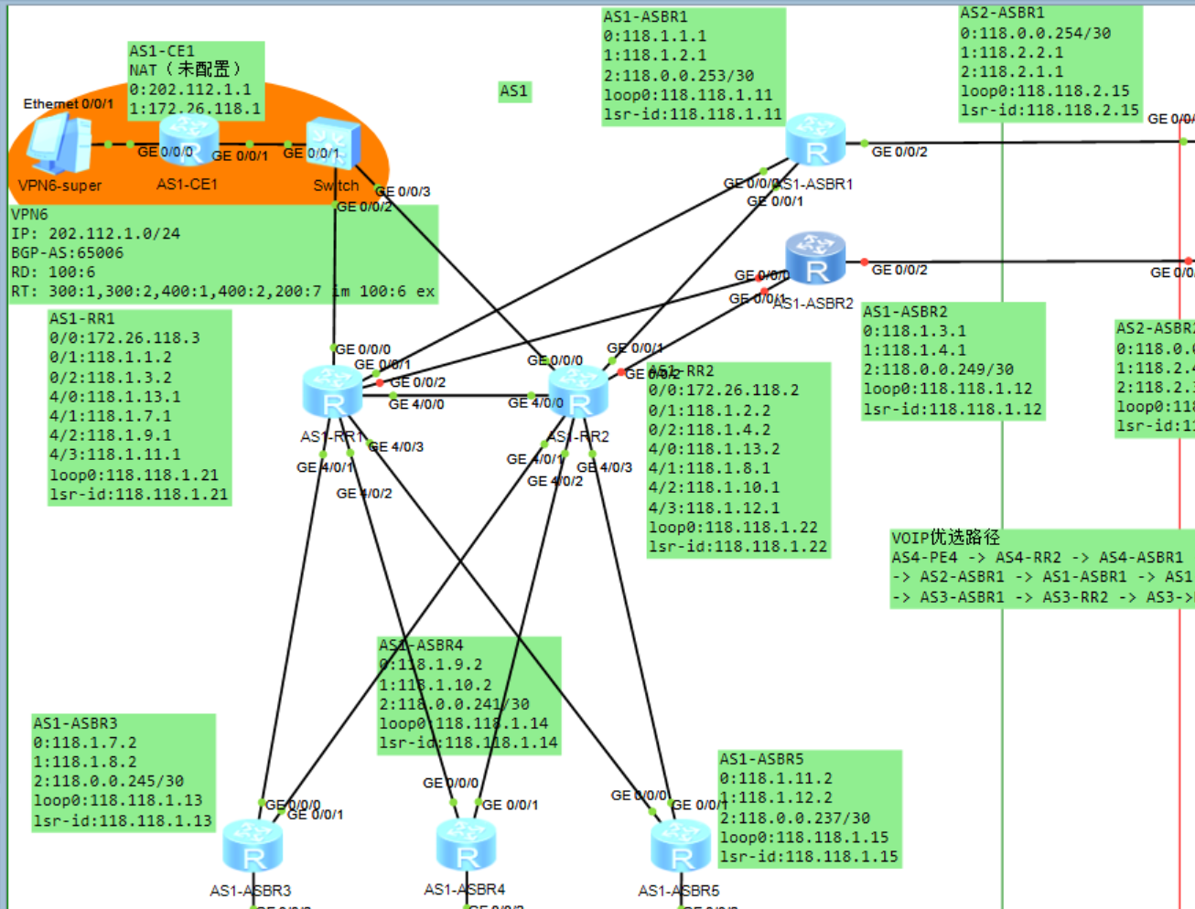

AS3:

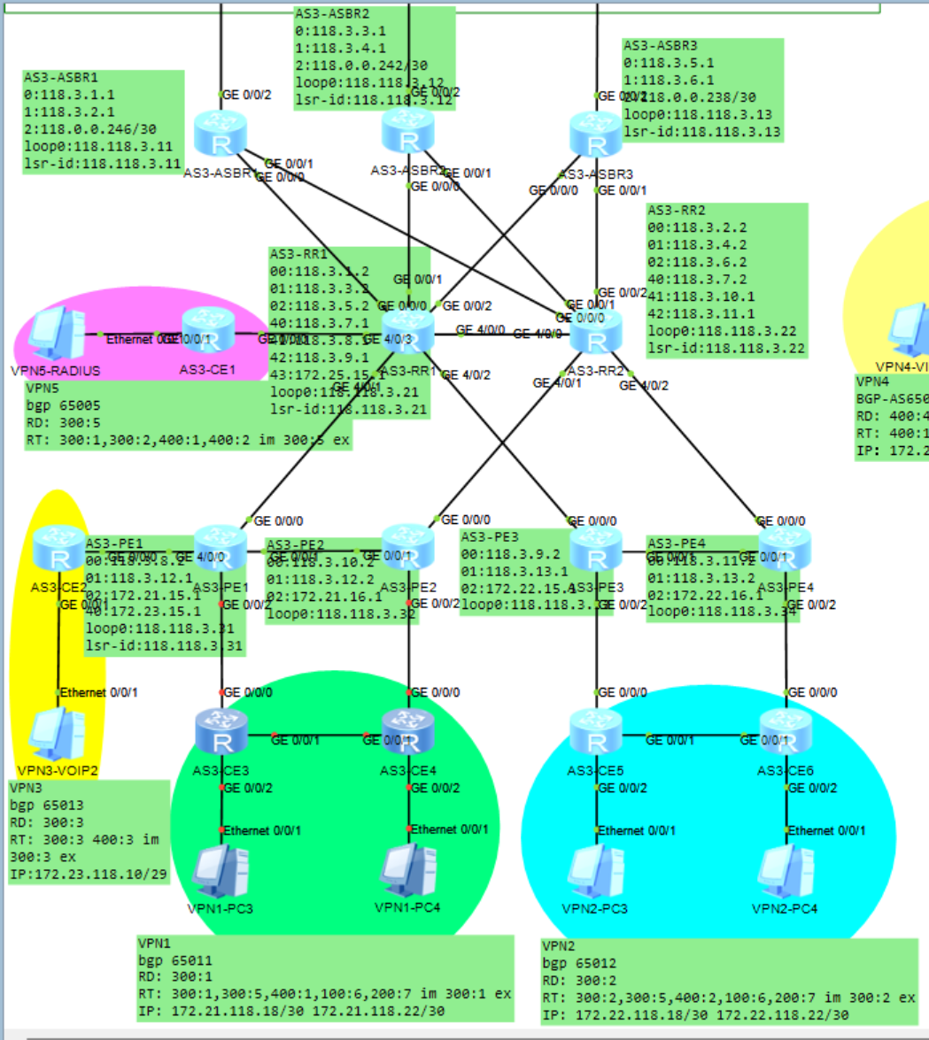

连通性

As2-as4

Vpn1-vpn4

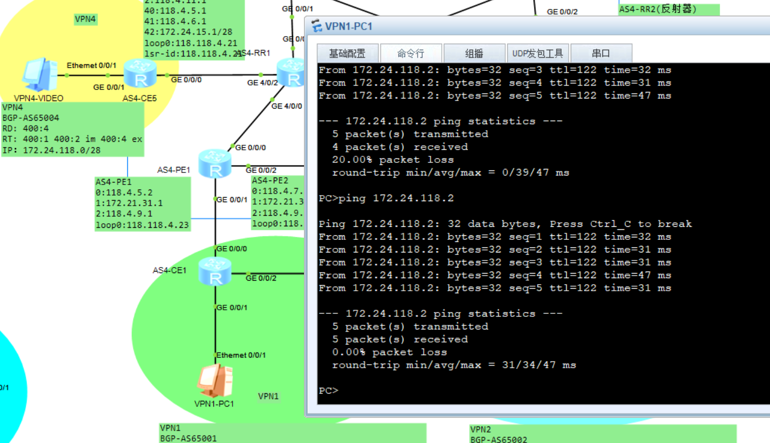

VPN2-VPN4

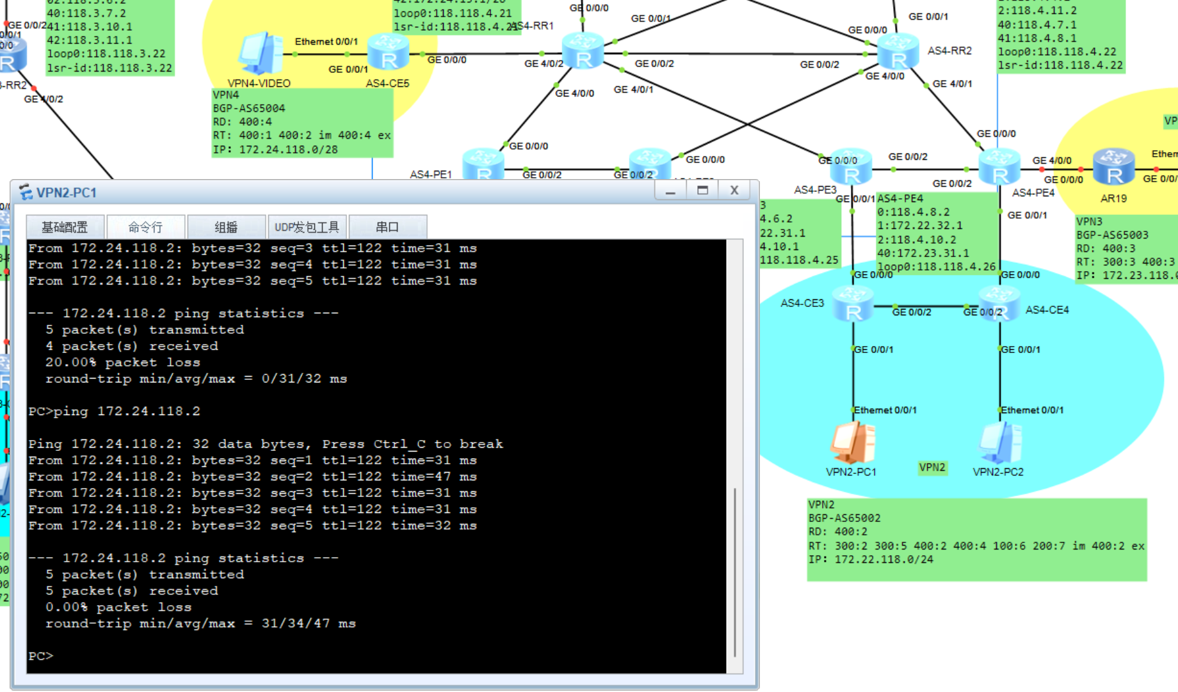

VPN1-VPN7

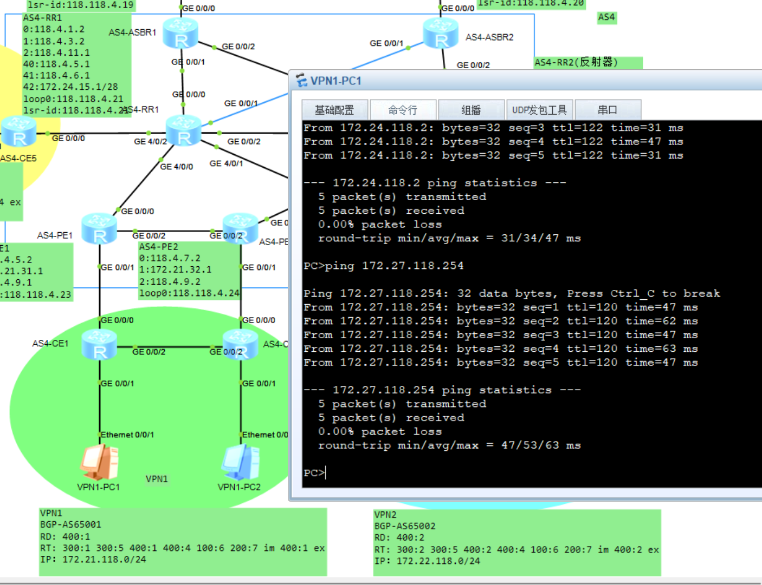

VPN2-VPN7

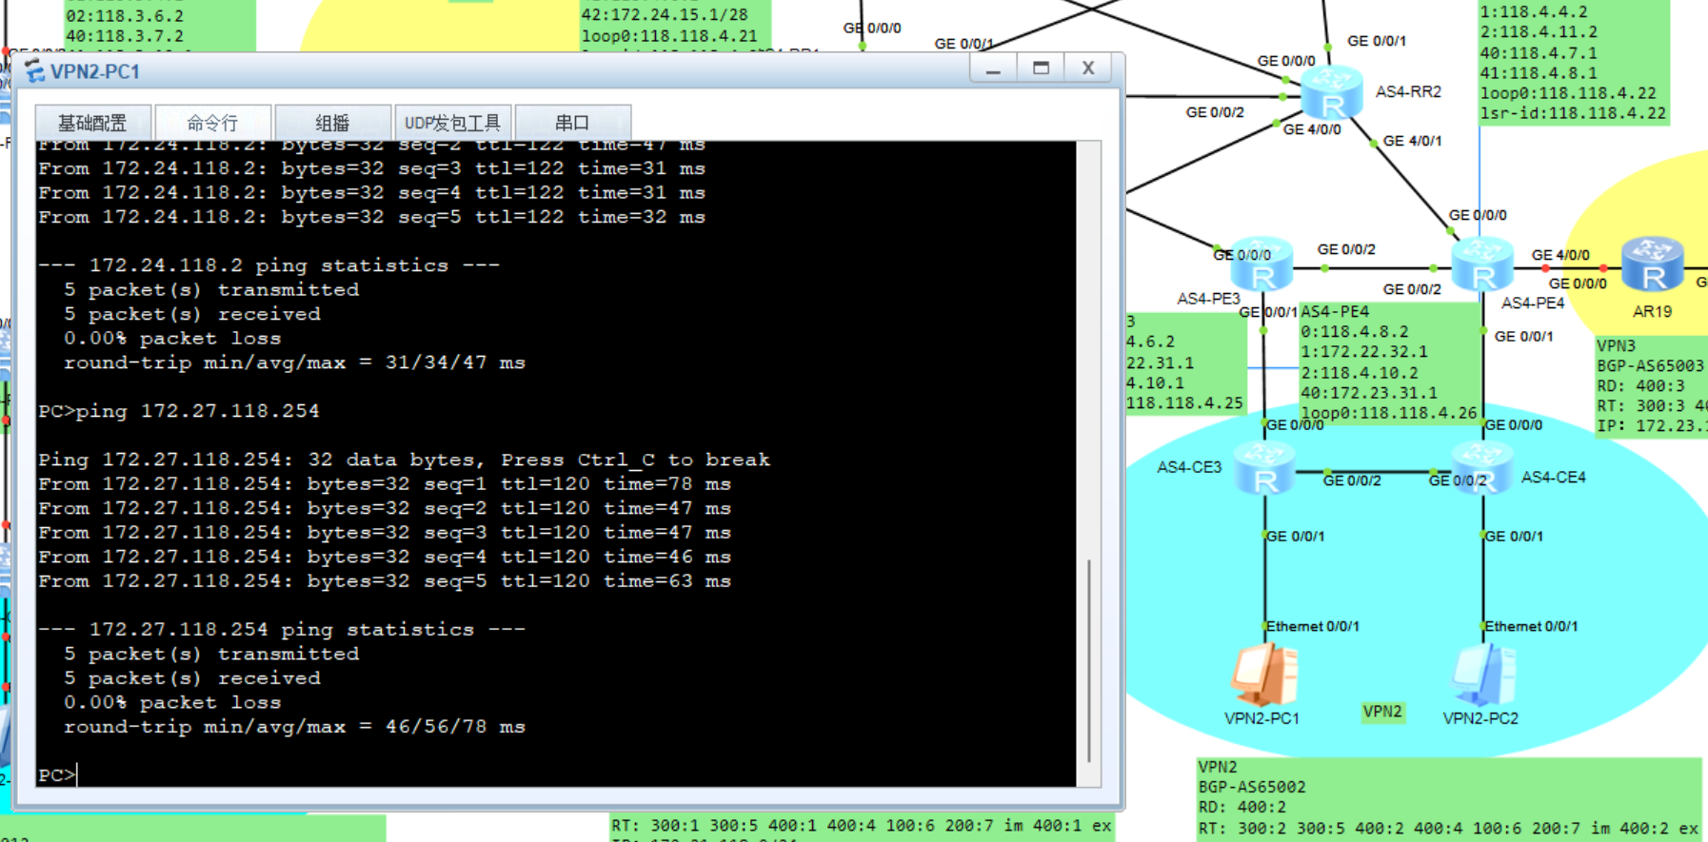

AS4:VPN1-VPN6

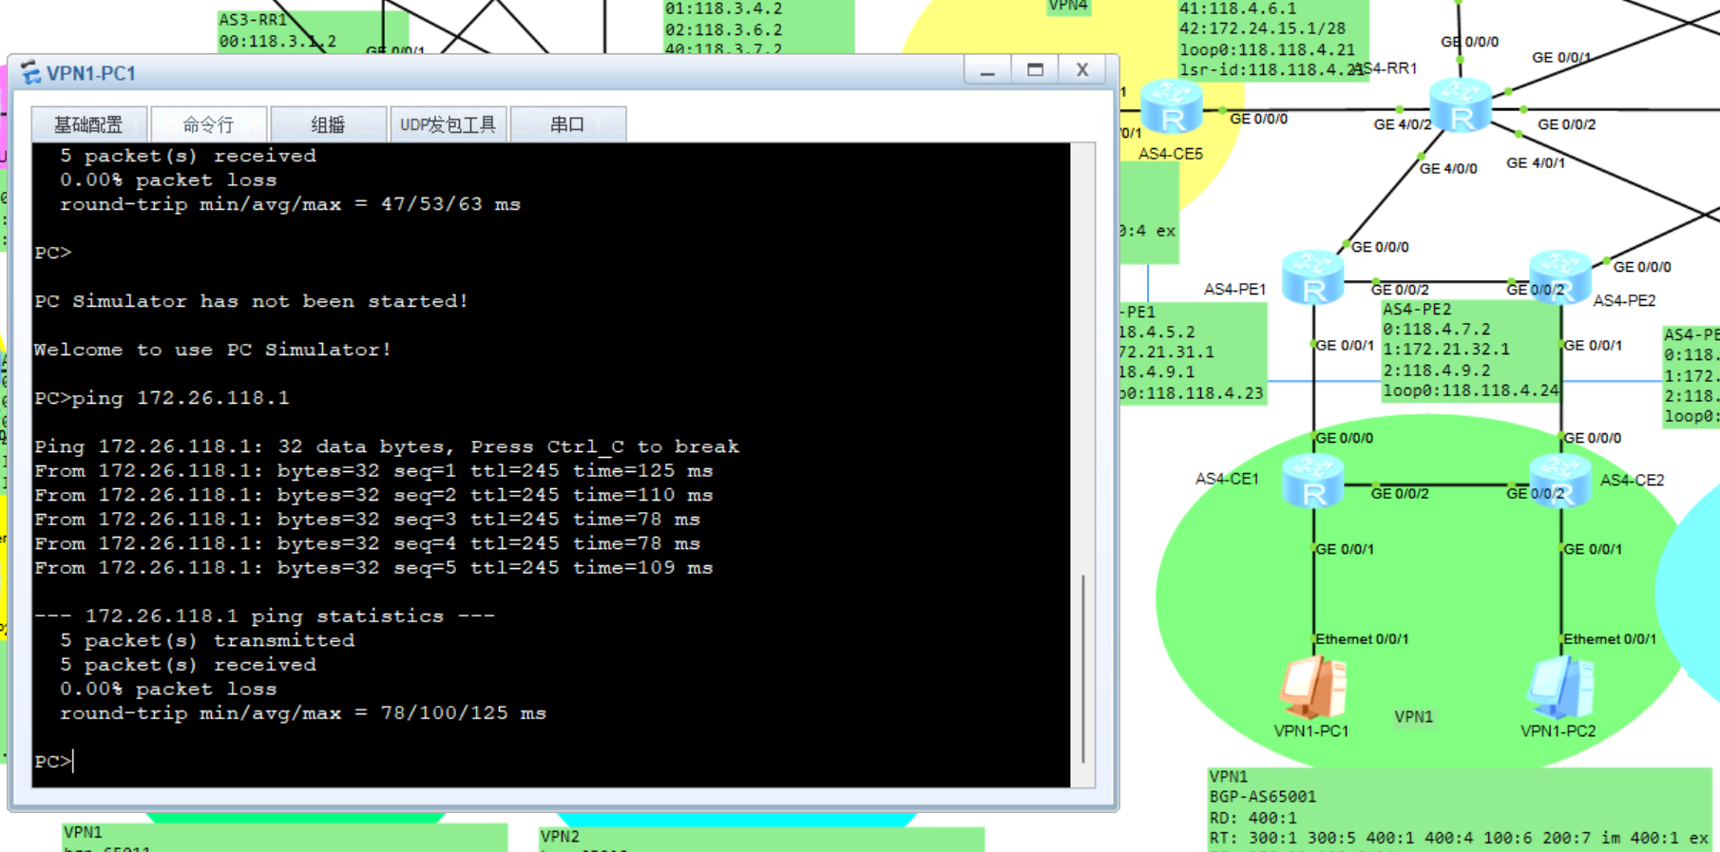

AS4:VPN2-VPN6

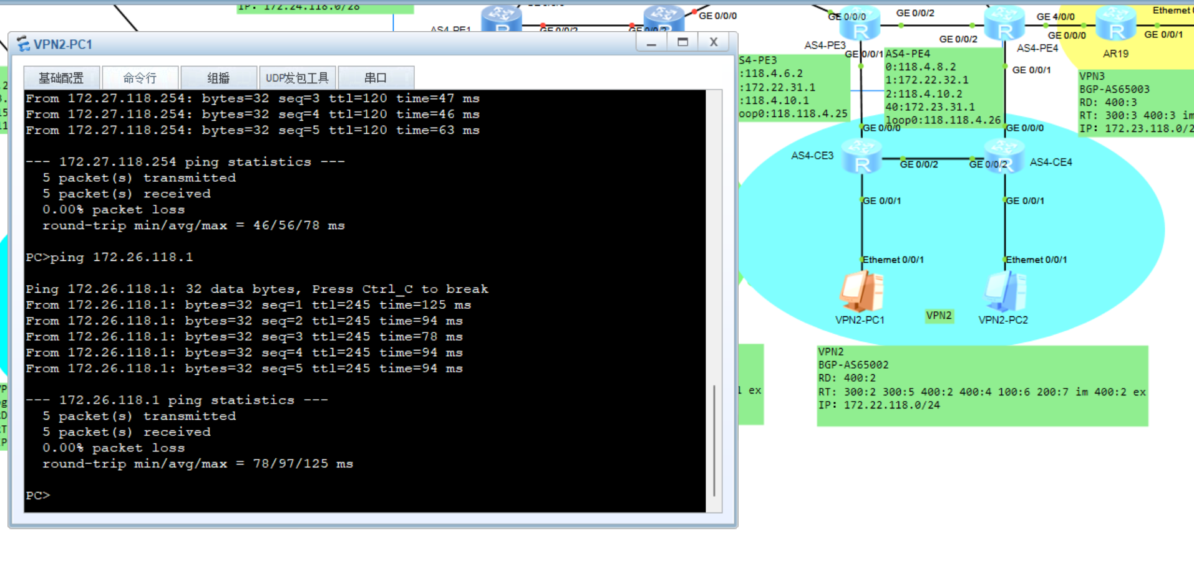

VPN6-VPN7

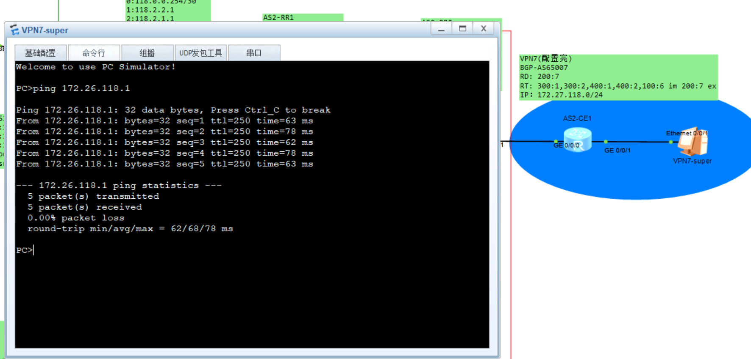

VPN1-VPN5

VPN2-VPN5

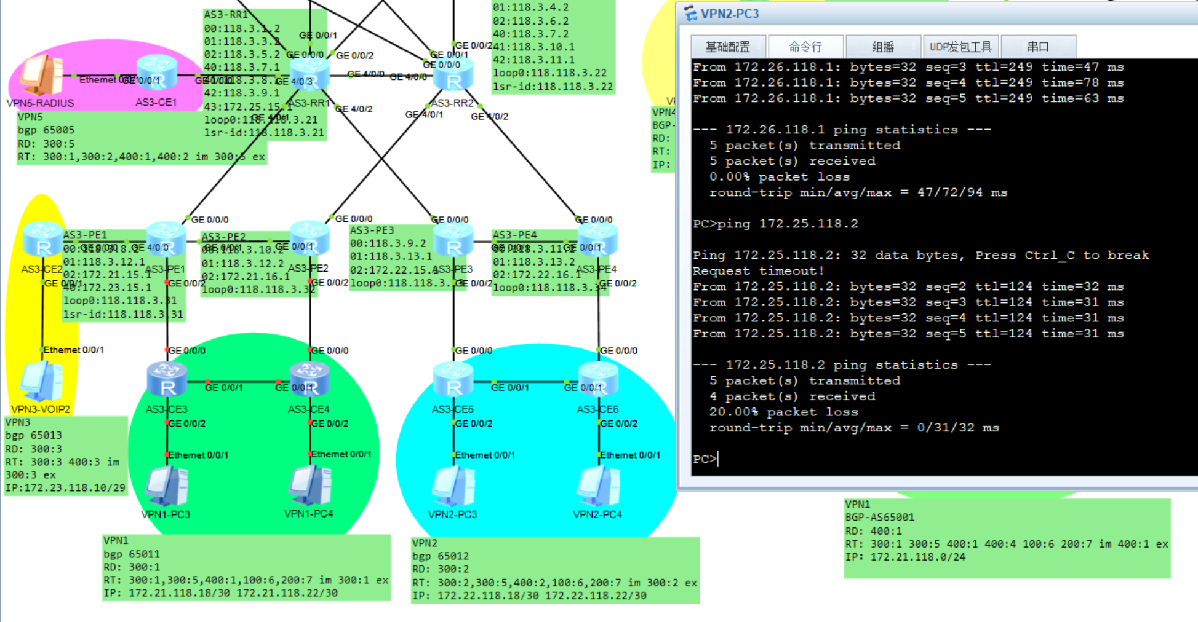

As3：VPN1-VPN6

As3：VPN2-VPN6

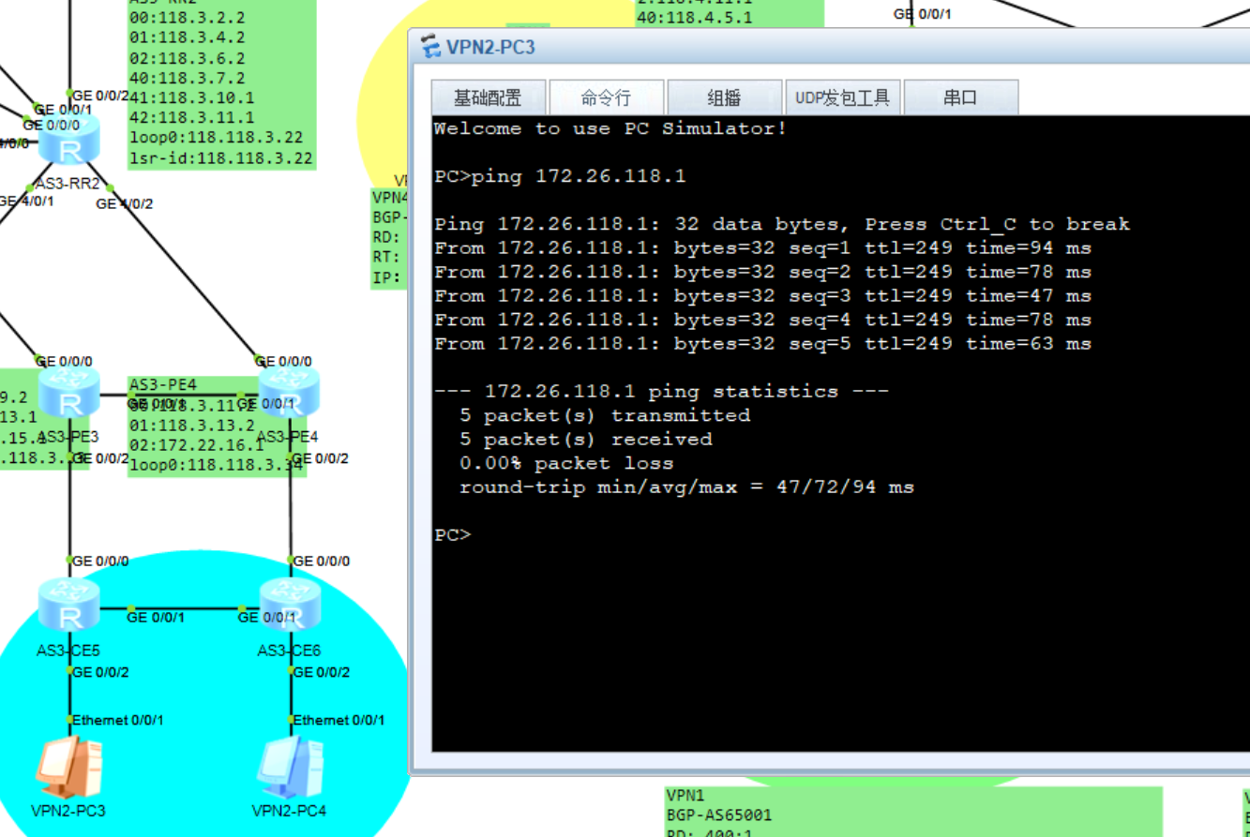

IP电话：

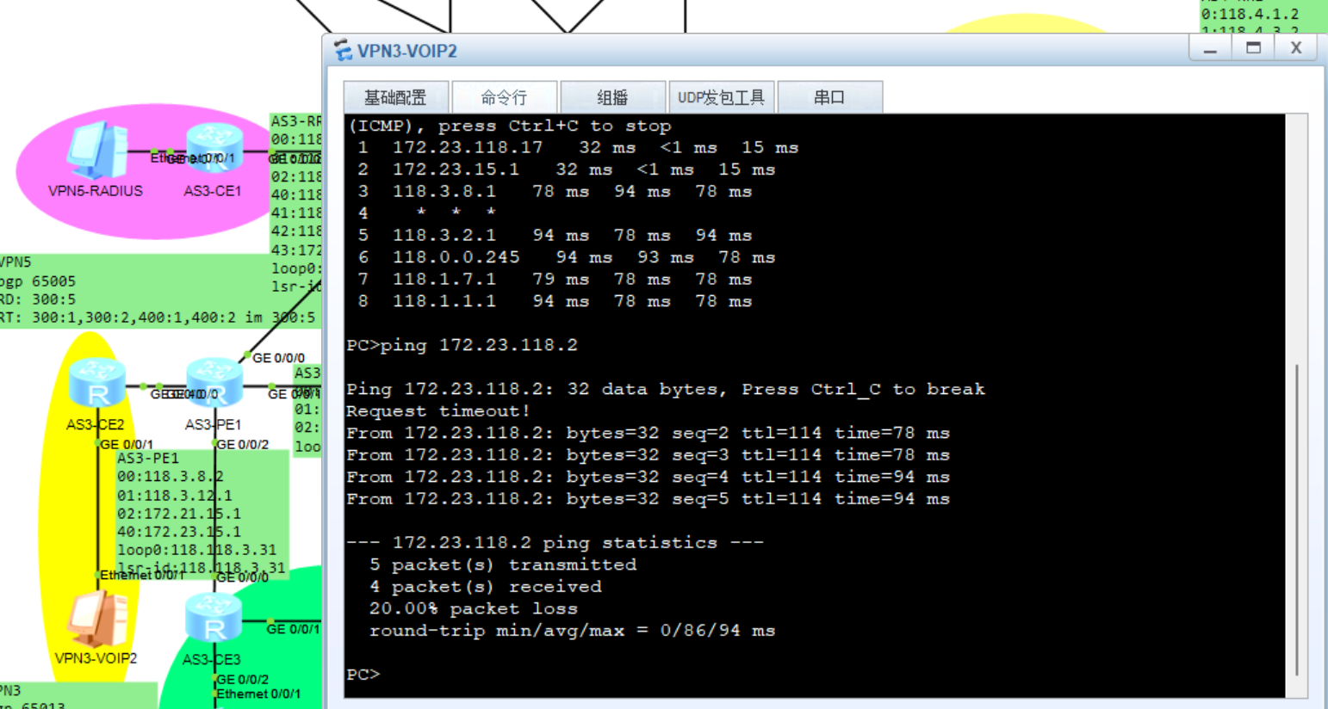

网管访问CE设备：

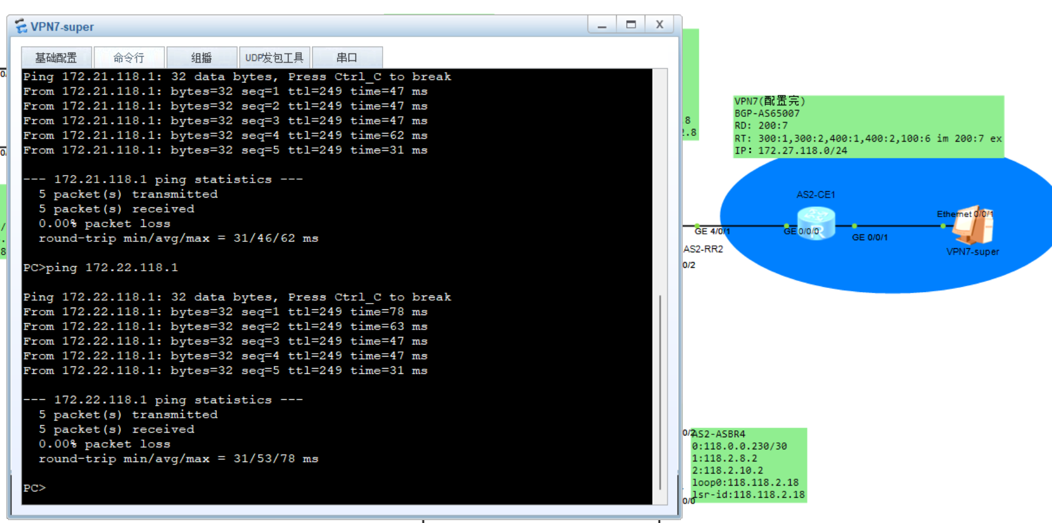

访问外网路由：

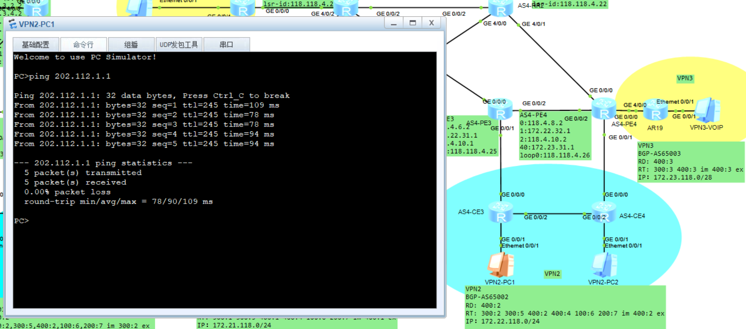

业务流隔离：

<AS4-CE3>dis ip routing-table

Route Flags: R - relay, D - download to fib

------------------------------------------------------------------------------

Routing Tables: Public

Destinations : 28 Routes : 28

Destination/Mask Proto Pre Cost Flags NextHop Interface

127.0.0.0/8 Direct 0 0 D 127.0.0.1 InLoopBack0

127.0.0.1/32 Direct 0 0 D 127.0.0.1 InLoopBack0

127.255.255.255/32 Direct 0 0 D 127.0.0.1 InLoopBack0

172.22.15.0/24 EBGP 255 0 D 172.22.31.1 GigabitEthernet

0/0/0

172.22.16.0/24 EBGP 255 0 D 172.22.31.1 GigabitEthernet

0/0/0

172.22.31.0/28 Direct 0 0 D 172.22.31.2 GigabitEthernet

0/0/0

172.22.31.2/32 Direct 0 0 D 127.0.0.1 GigabitEthernet

0/0/0

172.22.31.15/32 Direct 0 0 D 127.0.0.1 GigabitEthernet

0/0/0

172.22.32.0/28 EBGP 255 0 D 172.22.31.1 GigabitEthernet

0/0/0

172.22.118.0/28 Direct 0 0 D 172.22.118.1 GigabitEthernet

0/0/1

172.22.118.1/32 Direct 0 0 D 127.0.0.1 GigabitEthernet

0/0/1

172.22.118.15/32 Direct 0 0 D 127.0.0.1 GigabitEthernet

0/0/1

172.22.118.16/28 IBGP 255 0 RD 172.22.118.34 GigabitEthernet

0/0/2

172.22.118.32/28 Direct 0 0 D 172.22.118.33 GigabitEthernet

0/0/2

172.22.118.33/32 Direct 0 0 D 127.0.0.1 GigabitEthernet

0/0/2

172.22.118.47/32 Direct 0 0 D 127.0.0.1 GigabitEthernet

0/0/2

172.22.118.48/28 EBGP 255 0 D 172.22.31.1 GigabitEthernet

0/0/0

172.22.118.64/28 EBGP 255 0 D 172.22.31.1 GigabitEthernet

0/0/0

172.22.118.80/28 EBGP 255 0 D 172.22.31.1 GigabitEthernet

0/0/0

172.24.15.0/28 EBGP 255 0 D 172.22.31.1 GigabitEthernet

0/0/0

172.24.118.0/28 EBGP 255 0 D 172.22.31.1 GigabitEthernet

0/0/0

172.25.15.0/24 EBGP 255 0 D 172.22.31.1 GigabitEthernet

0/0/0

172.25.118.0/24 EBGP 255 0 D 172.22.31.1 GigabitEthernet

0/0/0

172.26.118.0/24 EBGP 255 0 D 172.22.31.1 GigabitEthernet

0/0/0

172.27.15.0/30 EBGP 255 0 D 172.22.31.1 GigabitEthernet

0/0/0

172.27.118.0/24 EBGP 255 0 D 172.22.31.1 GigabitEthernet

0/0/0

202.112.1.0/24 EBGP 255 0 D 172.22.31.1 GigabitEthernet

0/0/0

255.255.255.255/32 Direct 0 0 D 127.0.0.1 InLoopBack0

<AS4-CE3>